
Palmer Timeshare Claimants Group

December 2007

Dear

PALMER CLAIMANTS’ GROUP
DECEMBER 2007 – BULLETIN

I am writing to update you on the latest developments.

The Joint Trustees are in the process of selling Yucca Park and hope that the sale will be completed within the next three months. All of the sale proceeds relating to this resort will also have to be paid to the Spanish Authorities but once this payment has been made, the Joint Trustees are confident that all debts owed to the Spanish Authorities will have been paid in full.

As you are aware, the Spanish Court has agreed in principle to lift the criminal embargoes that are registered against the remaining resorts but there are still a number of legal hurdles to overcome. However, in the New Year, we hope that the Joint Trustees will be able to market the sale of the remaining resorts.

In relation to the hearing that was adjourned to 3 December 2007, after reviewing the matter further, the Joint Trustees decided that it was not necessary to obtain a declaration in respect of the remaining 27 companies and the application was withdrawn with the consent of all parties.

Unless there are any important developments that we need to report to you, our next bulletin will be sent to you in March 2008.

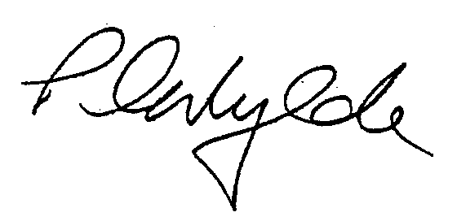
Yours sincerely

PETER WYLDE
PARTNER

